**Doctor App**

Abstract:

Life is becoming too busy to get medical appointments in person and to maintain a proper health care. The main idea of this work is to provide ease and comfort to patients while taking appointment from doctors and it also resolves the problems that the patients has to face while making an appointment. The android application Mr.Doc acts as a client whereas the database containing the doctor’s details, patient’s details and appointment details is maintained by a website that acts as a server.

INTRODUCTION:

If anybody is ill and wants to visit a doctor for checkup, he or she needs to visit the hospital and waits until the doctor is available. The patient also waits in a queue while getting appointment. If the doctor cancels the appointment for some emergency reasons then the patient is not able to know about the cancelation of the appointment unless or until he or she visits the hospital. As the mobile communication technology is developing rapidly, therefore, one can use the mobile’s applications to overcome such problems and inconvenience for the patients.

SOFTWARE DEVELOPMENT TOOLS:

The following software tools were used during the development process.

* JDK11
* Git
* MongoDB
* Junit5 & Mockito
* Eureka
* Spring Suite Tool
* Postman

HARDWARE DEVELOPMENT TOOLS:

The following hardware tools were used during the development process.

* CPU:2GHz Processor
* RAM:4GB
* HDD:1TB
* Display Resolution:1024*800

There are two services:

* Doctor service
* Patient Service

In Doctor service Doctor can upload the information and check the Information.

In Patient service Patient can upload the information and check the information.

User Story:

### For Patients

Doctor appointment booking apps grant patients an option to ‘Book Anytime, Anywhere’ and also allows easy access to doctors. Furthermore, the appointment booking feature makes the lives of elderly patients, and those who are suffering from life-long ailments or are bed-ridden more comfortable.

### **Cost Associated with eConsultation is less than in-person Visit**

An e-consultation visit costs 50 as compared to 130 for an urgent care facility visit and 740 for an emergency room visit. Furthermore, as per recent research, 71% of emergency room visits can be avoided. Most of the patients don’t need to visit the emergency department for minor health problems.

User will be able to search and generate report of Doctors.

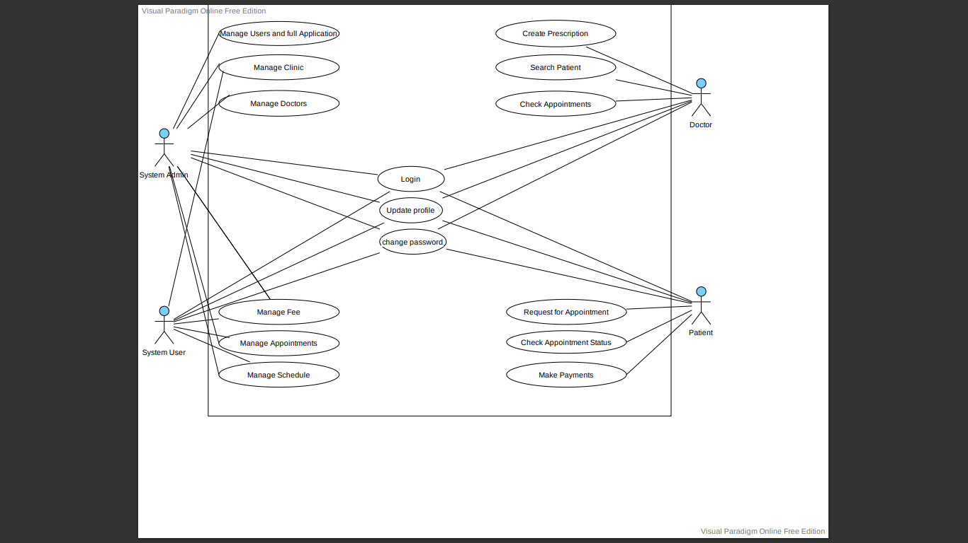

Use Case Diagram

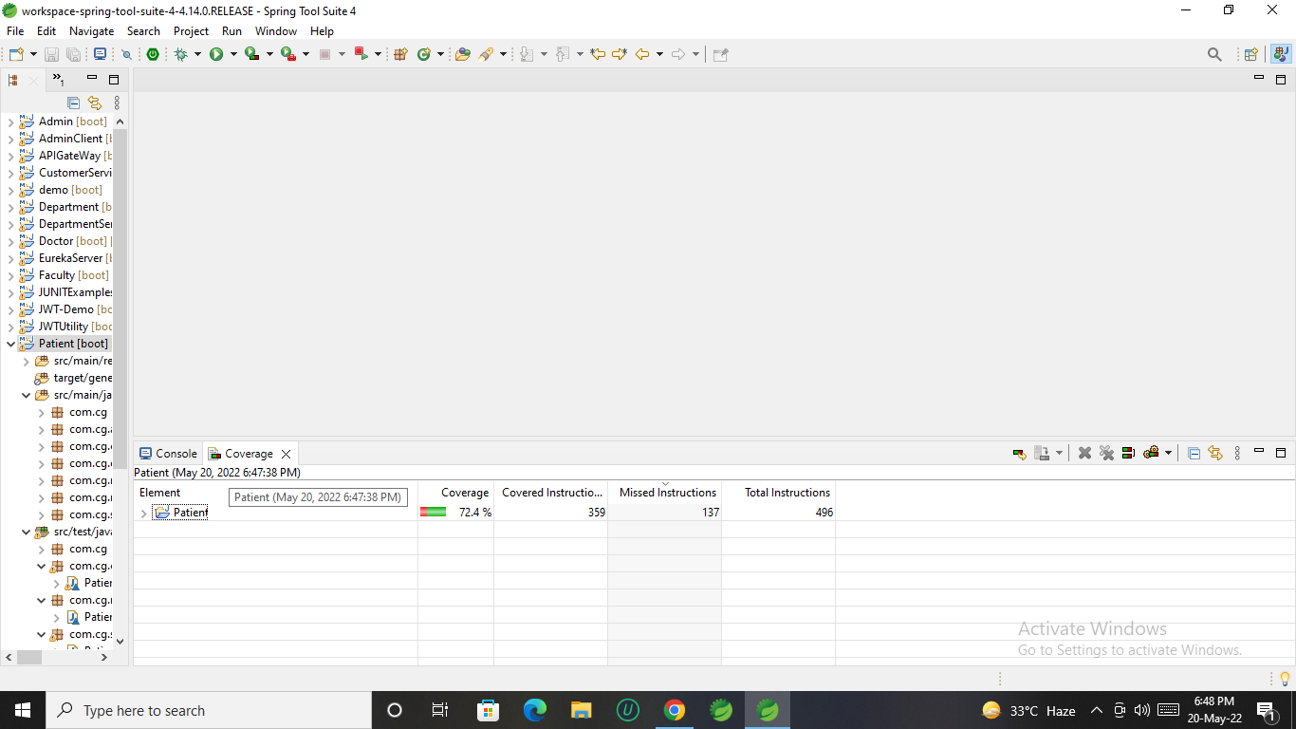

Code coverage

CONCLUSION AND FUTURE WORK :

The tasks involved in this work are divided into modules. The data is approached and shared by using API’S between the website and the android application. The proposed system is efficient and has friendly user interface. Addition of the location and doctor location on google in the android application are included in future work. That would help the patient to locate on the application and perform all the tasks on the app. The admin would be able to managing the details of the patients and the doctors of using the website. A payment or some amount may be charged to the users/patients while making an appointment to avoid the unethical users. As many users only register themselves just for fun and has no concern by making an appointment. Some more future directions are the improvements in the patient’s module which includes setting reminders for the appointments and saving the appointment date to the calendar.